**6. Implement program to apply moving average smoothing for data preparation and time series forecasting.**

|  |  |
| --- | --- |
| **EX.N0 : 6** | **Implement program to apply moving average smoothing for data preparation and time series forecasting.** |
| **DATE : 05/04/2025** |

**AIM:**

To Implement program to apply moving average smoothing for data preparation and time series forecasting.

**PROGRAM:**

import pandas as pd

import numpy as np

import matplotlib.pyplot as plt

# Sample population dataset (Year vs Population in millions)

data = {

'Year': np.arange(2000, 2021),

'Population': [1000, 1020, 1045, 1070, 1090, 1110, 1140, 1170, 1200, 1235,

1260, 1290, 1320, 1350, 1385, 1410, 1440, 1470, 1500, 1530, 1560]

}

df = pd.DataFrame(data)

# Moving Average Smoothing

window_size = 3 # You can change this for more/less smoothing

df['Smoothed_Population'] = df['Population'].rolling(window=window_size).mean()

# Plotting

plt.figure(figsize=(10, 5))

plt.plot(df['Year'], df['Population'], label='Original Population', marker='o')

plt.plot(df['Year'], df['Smoothed_Population'], label=f'{window_size}-Year Moving Average', linestyle='--', color='red')

plt.xlabel('Year')

plt.ylabel('Population (millions)')

plt.title('Population Growth with Moving Average Smoothing')

plt.legend()

plt.grid(True)

plt.tight_layout()

plt.show()

**OUTPUT:**

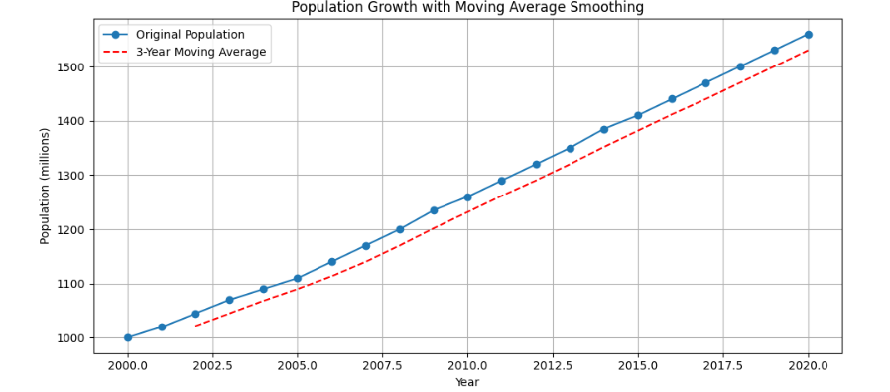

**RESULT:**

Thus, the program for Implement program to apply moving average smoothing for data preparation and time series forecasting is executed successfully.